USB Keyboard
USB Compact Multimedia Keyboard
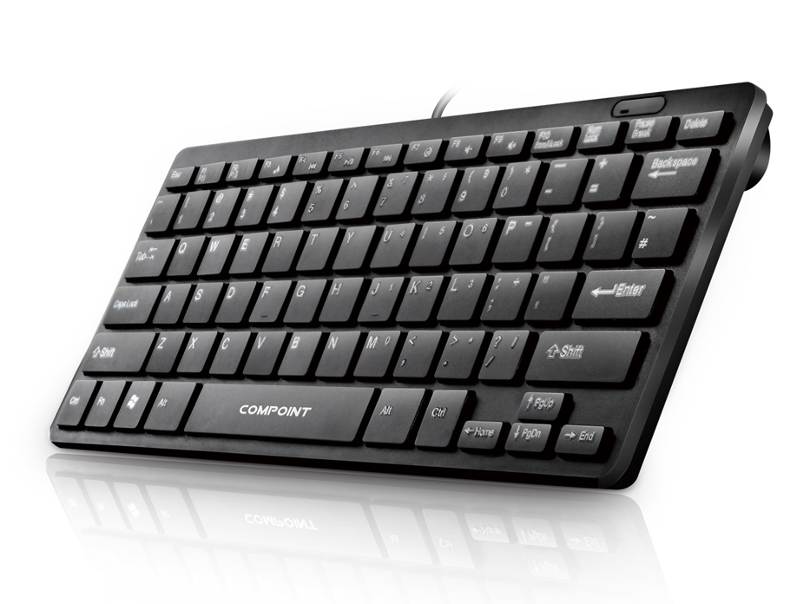

Descrption:

More than just good looks..

The new CP-K7070 is your ideal travel or light-user partner for desktop, notebook and of course mobile computing devices that are fitted with a USB port. Offering a full multimedia control experience for nearly all your applications, complete with a low profile and compact design means it can be taken anywhere you go and perfectly fits into most notebook and messenger carry bags. Ideal for project computers too, like the Raspberry PITM.

ldeal for more than just Notebook Computers..

Being totally Plug n' Play, the CP-K7070 is ideal for almost any tablet computer which has either a built-in USB port, or if necessary, one can be fitted via an external adapter. Using the CP-K7070 greatly increases the usability of tablet computers, meaning better productivity, faster and more accurate typing and of course complete control of almost all tablet apps.

Features:

Compact and stylish

Ideal for Notebooks and Tablets

Low-profile with tactile feedback

Standard USB Plug n' Play interface

Durable, approx. 10 million keystrokes

Common multimedia control buttons

WindowsTM shortcut keys

Raspberry PITM compatible

Specifications
- Material：ABS or ABS+Metal
- Keyboard Standard: 78 Keys
- Port: USB
- Certificate: CE FCC ROHS
- Operating Temperature:0℃ to +45℃
- Operating Humidity:10%0 to 85 % RH
- Storage Temperature : -10℃ to +55℃
- Storage Humidity: 5% to 90 % RH

Product Code:
Part number: K7070
Barcode: 8400800025876
Size: 285mm*125mm*5mm
Weight: 0.600 kg

